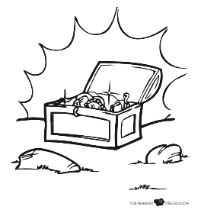
Baúl de Palabras
- _____________
- _____________
- ____________
- _____________
- ___________
- ___________
- _____________
- ___________
- ____________
- _____________
- ___________
- ___________
- _____________
- _____________
- __________
- ___________
- _____________
- ______________
- ______________
- _____________
- ____________
- ___________
- __________
- _________
- __________
- ____________
- __________
- ________________
- ________________
- ________________
- ________________
- ________________
- ________________
- ________________
- ________________
- ________________
- ________________
- ________________
- ________________
- _____________
- ______________
- ____________
- _____________
- ______________
- ______________
- ______________
- ____________
- _____________
- ____________
- _________
- _____________
- ________________
- ______________
- ________
- ________________
- ________________
- _____________
- ______________
- ________________
- _______________
- _______________
- _____________
- ________________
- ______________
- ________________
- _______________
- _______________
- _______________
- ________________
- ____________
- ____________
- ____________
- _____________
- ____________
- ______________
- ____________
- ____________
- _____________
- ____________
- ______________
- _____________
- ____________
- ____________
- ____________
- _____________
- _____________
- ____________
- _____________
- _____________
- _____________
- ____________
- ______________
- ____________
- ______________
- ____________
- ____________
- ______________
- _____________
- _____________

