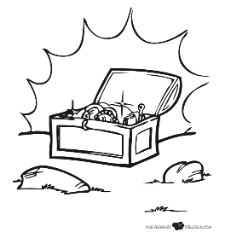
Baúl de Palabras
- __Equinoccio_
- __Aurora___
- ___Navío_
- __Bordar____
- __Arcoíris__
- __Roció___
- ___Rayo___
- ____Acuático__
- __imán___
- ______orbita_
- ____sepultura
- _aéreo__
- __lengua____
- _ suspiro_____
- ___quitasol__
- __aliento___
- ____marea__
- ___ alba___
- ___espacial_____
- ____estelar__
- _____nemoroso_
- ___sediento ___
- __intempesta__
- _____Aletargar__
- ______Acicalar_
- ____________
- __________
- ________________
- ________________
- ________________
- ________________
- ________________
- ________________
- ________________
_____________
- ________________
- ________________
- ________________
- ________________
- ________________
- ____________________________
- _____________
- ______________
- ____________
- _____________
- ______________
- ______________
- ______________
- ____________
- _____________
- ____________
- _________
- _____________
- _________________________
- ______________
- ________
- ________________
- ________________
- _____________
- ______________
- ________________
- _______________
- _______________
- _____________
- ________________
- ______________
- ________________
- _______________
- _______________
- _______________
- ________________
- ____________
- ____________
- ____________
- _____________
- ____________
- ______________
- ____________
- ____________
- _____________
- ____________
- ______________
- _____________
- ____________
- ____________
- ____________
- _____________
- _____________
- ____________
- _____________
- _____________
- _____________
- ____________
- ______________
- ____________
- ________________________
- ____________
- ____________
- ______________
- _____________

